SECTION 1: Title and Reporting Relationships
Position title: | DC Operations Administrator |  |  | Location: | Whakatu, Hastings
Business unit: | Distribution Centre |  |  | Organisation unit: | Distribution Centre
Reports to: | DC Operations Manager
Direct Reports: | None

Primary Purpose:
The purpose of this role is to;
- Provide timely and accurate administration support
- Ensure all key administration tasks are managed to ensure the efficient daily operation of the Distribution Centre
- Provide oversight of all inbound and outbound stock movements and investigate discrepancies
- Be the key liaison for all Starbucks queries, orders and stock management

Section 2: Key Results Areas
1st KPI Area
- To complete all administration and stock management tasks accurately and within the required timeframes.
2nd KPI Area
- Accurate and efficient service to online Starbucks customers and Support Hub with limited complaints or damaged product.
3rd KPI Area
- Effectively manage all inbound and outbound stock transfers and investigate any discrepancies in a timely manner.
4th KPI Area
- Deliver a superior customer service experience that ensures all communication is accurate and provided within a timely manner

SECTION 3: Role Accountabilities
Operational Support
- Provide a high level of customer service when communicating with Stores, Support Hub and external stakeholders, including;
- Stationery and bags
- Meet the response expectation of within 24 hours, same day if urgent
- Able to provide cover for the DC Operations Co-ordinator including all of their day to day tasks
- Assist with annual stocktake

Starbucks online orders
- Monitor all online orders. Process in a timely manner with the appropriate packaging
- Maintain accurate stock records and action all required admin associated with Starbucks
- Liaise with the Starbucks operations team (Support Hub) as required
- Provide the necessary training and supervision as required
- Respond to all Customer Service queries relating to customer orders in a timely manner (the same or next business day)

Ecom
- Action all Ecom returns and exchanges accurately and in a timely manner

Stock Management
- Proactively, run and review reporting to manage stock deliveries and outstanding transfers. These are to be reconciled weekly.
- Manage all stock on HOLD
- Maintain oversight of all stock returned from stores awaiting sort and putaway

System processes
- Demonstrate full competence and understanding of all system processes. Provide support and advice when reviewing system changes. Able to troubleshoot as required.
- Provide troubleshooting to the inbound team and tasks (eg: ratio allocations)
- Investigate stock and barcodes of stock not scanning on the conveyor

Administration
- Complete all inbound receipting paperwork in advance of devanning. Receipt inbound stock both FCL and LCL
- Complete general administration tasks as required (Eg bulk orders, wholesale tasks, registers, labels)
- Accurately monitor and maintain the reworks registers, submitting cost claims as required
- Assist planning/buying team with queries and sample requests
- Create manual transport consignments
- Produce barcodes and location labels as required
- Ensure printed ample pallet ID’s available at all times
- Manage all stationery, bags and POS requests
- Manage all onsite POS storage and distribution
- Maintain tidy lundia aisle
- Responsible for running and emptying of dishwasher in the staff lunch room

General Health & Safety
- Comply with relevant legislation in relation to your own duties and work environment, including observing all internal safety procedures and policies, adopting healthy and safe work practices, reporting any hazards or accidents and ensuring that no action or inaction by you while at work, shall cause harm to yourself or any other person.
- Ensure you and your team proactively look to create an environment of wellness across the team and working environment.

General Tasks
You may be asked from time to time to complete tasks out of the scope of this job description.

SECTION 4: Key Relationships
People and organisations both inside and outside of the company that this position would be required to manage relationships with.
Internal |  |  | External
- Group Logistics Manager  - DC Operations Manager  - DC Operations Co-ordinator  - Team Leads  - Support Hub  - Starbucks team  - Store Managers |  |  | - Transport Companies  - Suppliers

SECTION 5: Our Values
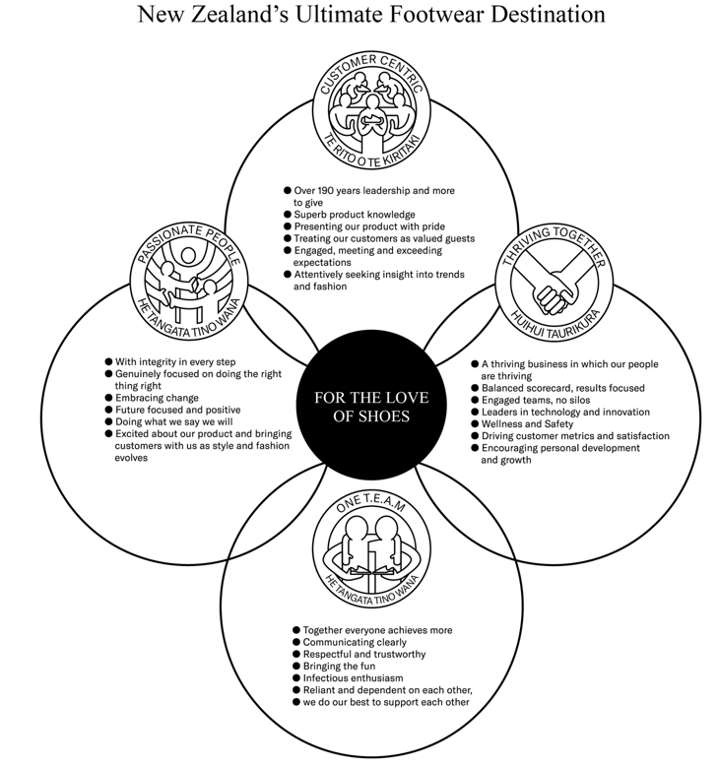

SECTION 6: Skills & Qualifications, Knowledge, Behaviours
Skills & Qualifications |  | Behaviours
- Competent in Microsoft Excel  - Excellent oral and written communication  - Ability to take and follow directions  - Ability to multi-task  - Excellent time management and ability to work to deadlines  - Experience with warehouse management systems – preferred |  | - Able to work autonomously and use initiative  - Able to adapt to new systems quickly  - Able to work collaboratively  - Able to demonstrate attention to detail  - Can demonstrate the ability to problem solve  - Able to think critically  - Excellent interpersonal skills and behaviours

SECTION 7: Confirmation
This Position Outline is an overview guideline for your position to ensure both your People Leader and you are aware of the day-to-day requirements in this role. It does not in any way limit the use of your entrepreneurial skills or being assigned any other projects and/or tasks as initiated by your manager and must be read in conjunction with the objectives and goals set annually in relation to the Business objectives and plans.

This position outline has been discussed and agreed:

Manager: Jo McIndoe Employee: Bailey Hawthorne

Signed:____________________________________ Signed:_____________________________________

Date:______/_________/________ Date:______/_________/________

SECTION 8
Author: | Jo McIndoe | Approver: | Jo McIndoe | Date: | 10/10/25
Amended by: | Jo McIndoe | Approved By: | Jo McIndoe | Date: | 10/10/25

