SECTION 1: Title and Reporting Relationships
Position title: | DC Operations Co-ordinator |  |  | Location: | Whakatu, Hastings
Business unit: | Distribution Centre |  |  | Organisation unit: | Distribution Centre
Reports to: | DC Operations Manager
Direct Reports: | None

Primary Purpose:
The purpose of this role is to provide;
- Support the DC Operations Manager to ensure the efficient daily operation of the Distribution Centre
- Proactively review and analyse stock management and people performance opportunities
- Provide timely and accurate administration support to the Group Logistics Manager to fulfil reporting and stock integrity requirements

Section 2: Key Results Areas
1st KPI Area
- To provide support with promoting, managing and reporting on operational, people performance and stock management to create an environment that encourages and promotes operational excellence.
2nd KPI Area
- Meet all reporting deadlines and demonstrate a proactive approach to investigations, auditing and reporting requirements to maintain stock accuracy.
3rd KPI Area
- Daily supervision of the Ecom team tasks to ensure customer expectations are met consistently and orders are dispatched within the appropriate timeframe commitment.
4th KPI Area
- Deliver a superior customer service experience that ensures all communication is accurate and provided within a timely manner

SECTION 3: Role Accountabilities
Operational Support
- Provide day to day support to the DC Operations Manager including:
- In the DC Operation Managers absence, oversee the day to day running and completion of tasks required
- Provide hands on support where necessary
- Assist with time and attendance tasks and systems
- Lead as required and assist with annual stock take
- Complete conveyor auditing and investigations, providing constructive feedback to the DC Operations Manager
- Provide a high level of customer service when communicating with Stores, Support Hub and transport companies, including;
- Responsible for overseeing the response to all DL-DC emails received
- Regularly reviewing and managing all Fresh Service tickets allocated to the DC
- Meet the response expectation of within 24 hours, same day if urgent
- Able to provide cover for the DC Operational Administrator including all of their day to day tasks

ECOM Team Lead
- Provide the necessary training and supervision to the team
- Oversee the day to day running of the Ecom team and completion of required tasks, accurately and within the required timeframes
- Ensure any performance issues are raised with the DC Operations Manager
- Proactively review opportunities to improve processes and efficiency
- Respond to all Customer Service queries relating to customer orders in a timely manner (the same or next business day)

Stock Management
- Proactively, run and review reporting to manage stock discrepancies and opportunities – generating these reports individually from excel
- Complete stock management investigations including lost stock investigations and stock with no location – generating the required reports and stock movement details
- Monitor transfers outstanding

System processes
- Demonstrate full competence and understanding of all system processes. Provide support and advice when reviewing system changes. Able to troubleshoot as required.
- Schedule and manage all pick management tasks
- Complete ratio pack allocation reconciliations
- Complete regular clear floor adjustments

Administration
- Review and complete all invoice approvals including local and overseas suppliers
- Co-ordinate DC facilities maintenance activities and maintain central register
- Responsible for purchasing of general items (Eg stationary, tea/coffee etc, items via Office Max) and other adhoc items requested
- Complete uniform orders and manage requests and distribution
- Order chep pallets as required to ensure we have a suitable quantity available at all times for the tasks being completed
- Complete general administration tasks as required (Eg bulk orders, wholesale tasks, registers, labels)

Reporting
- Complete the following reporting as and when required;
- Weekly DC Output
- Monthly DC Output
- Incoming and container schedule
- Delay analysis
- Shipping cost per unit
- Other reports as required

Workplace Health and Safety
- Provide support to the DC Operations Manager as required and specifically with the following;
- demonstrate leadership in personally complying with all relevant legislation and company policies and promoting safe practices
- report promptly any yellow card incidents
- onsite H&S inductions as required
- maintaining all relevant registers (Eg forklift and first aid licences, MPI certification)
- maintain all first aid kits onsite

General Health & Safety
- Comply with relevant legislation in relation to your own duties and work environment, including observing all internal safety procedures and policies, adopting healthy and safe work practices, reporting any hazards or accidents and ensuring that no action or inaction by you while at work, shall cause harm to yourself or any other person.
- Ensure you and your team proactively look to create an environment of wellness across the team and working environment.

General Tasks
You may be asked from time to time to complete tasks out of the scope of this job description.

SECTION 4: Key Relationships
People and organisations both inside and outside of the company that this position would be required to manage relationships with.
Internal |  |  | External
- Group Logistics Manager  - DC Operations Manager  - DC Operations Administrator  - Team Leads  - Support Hub  - Regional Managers  - Store Managers |  |  | - Transport Companies  - Suppliers and training providers

SECTION 5: Our Values
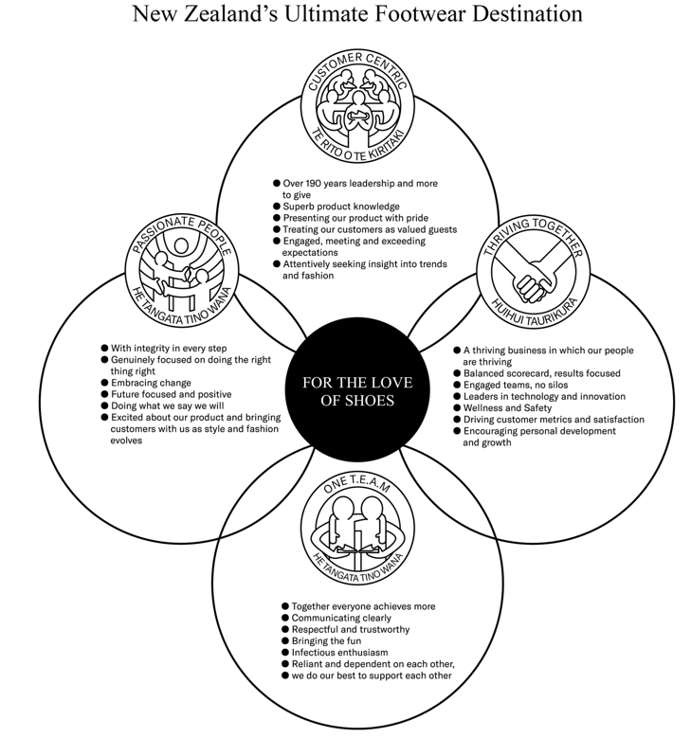

SECTION 6: Skills & Qualifications, Knowledge, Behaviours
Skills & Qualifications |  | Behaviours
- High level of competence using Microsoft Excel – particularly experience with V look ups and generating reporting from data  - Competent in Microsoft Office  - Excellent oral and written communication  - Practiced at maintaining a high level of confidentiality  - Ability to multi-task  - Excellent time management and ability to work to deadlines  - Experience with warehouse management systems – preferred |  | - Able to work autonomously and use initiative  - Able to adapt to new systems quickly  - Able to effectively lead a team to achieve positive results  - Able to manage conflict effectively  - Able to work collaboratively  - Can demonstrate the ability to problem solve  - Is adaptable to changing situations  - Able to think critically  - Excellent interpersonal skills and behaviours

SECTION 7: Confirmation
This Position Outline is an overview guideline for your position to ensure both your People Leader and you are aware of the day-to-day requirements in this role. It does not in any way limit the use of your entrepreneurial skills or being assigned any other projects and/or tasks as initiated by your manager and must be read in conjunction with the objectives and goals set annually in relation to the Business objectives and plans.

This position outline has been discussed and agreed:

Manager: Jo McIndoe Employee:

Signed:____________________________________ Signed:_____________________________________

Date:______/_________/________ Date:______/_________/________

